
Department of Computer Science and Engineering
Lab Report
Lab Report No | : | 04
Lab Report Name | : | Fixed Position Method Implementation. F(x)= 3x-cos(x)-1.
Course Title | : | Numerical Methods Sessional
Course Code | : | CSE 226
Name | : | Gazi Rishad Kaiser
ID | : | 1120047
Level | : | 2 | Term | : | 2 | Section | : | A | Group | : | 2
Date of Submission | : | - 2026 | Semester | : | Spring | Year | : | 2026

Problem: Fixed Point Method. F(x)= 3x-cos(x)-1.
Key Learnings:
- This program helped in understanding the Fixed Point Iteration Method, which is used to find the root of an equation by repeatedly using an initial approximation to generate a better estimate.
- The importance of choosing a suitable initial guess was learned. A good starting value helps the method converge more quickly to the correct root.
Source Code: Input & Output:
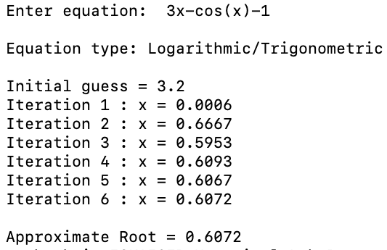
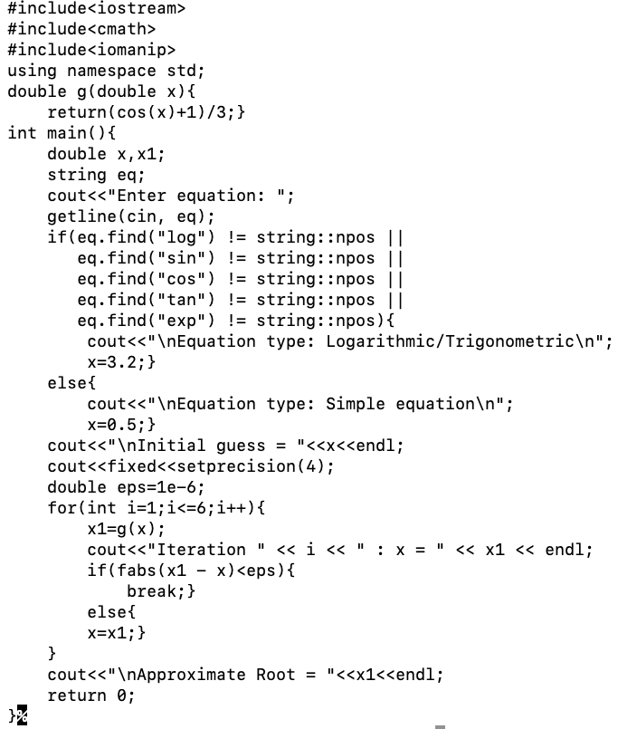

Input & Out

Result Analysis
When the program was executed, an initial guess and the required number of iterations were provided. The Fixed Point Iteration Method was then applied repeatedly to generate successive approximations of the root. In each iteration, the previous value was substituted into the iteration formula to obtain a new estimate. As the iterations progressed, the difference between consecutive values became smaller, indicating that the solution was approaching a stable value. The root estimate gradually converged toward the actual solution of the equation. After the specified number of iterations, the final approximation of the root was displayed on the screen.
